PyCity Schools Observation

1. **Scores by School Spending.**

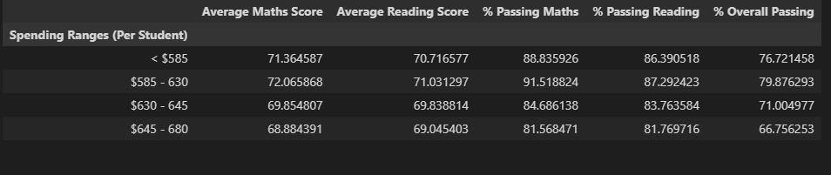

Based on this table, if the school spends between $585 and $630 per students, students are likely to achieve a better result than spending less than $585. However, above this spending amount ($585-$630), the percentage passing marks and the average score start to decrease. It can be interpreted that the students would unlikely to achieve a high score mark if they received too much money

1. **Scoresby school size:**

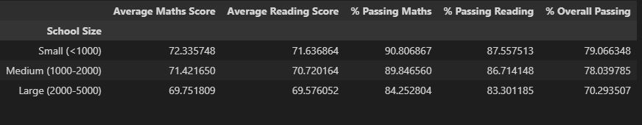

From the above table, it can be stated that if the school has less than 1000 students, they tend to achieve a better result than schools with medium and large size. The more students that the school has, the more resources/expense they need to spend to meet up with student’s demand. As a result, they ran out of budget to provide a high quality service to each students to improve an academic level.

1. **Scores by school type:**

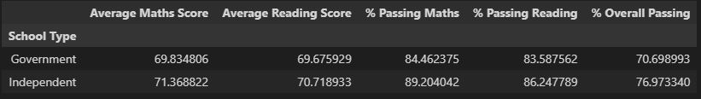

Based on the above table, students from independent schools tend to achieve a better academic result than students from Government schools. This can be explained that students in independent schools would receive a better care from teachers due to small size of students in each classroom and receiving a better fund than public/government schools.